Name Date_______________
Assignment: DN, 7th Grade Math Team ______________

Do Now: Lesson 66
Directions: Show all work using MOLE.
1 | [standard] | Which of the following shows $10-4(3x-1)$ in simplified form?  - $12x+14$  - $12x+11$  - $-12x-14$  - $-12x+14$
2 | [standard] | Which of the following values of k satisfies the equation $5(2k+1)=35$ ?  - 3  - 4  - 12 ½  - 14 ½
3 | APK | Which table shows a proportional relationship between x and y?  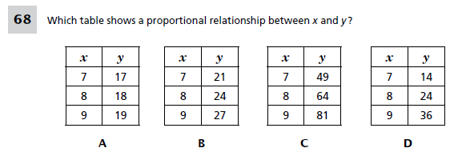
4 | APK | Which of the following shows a proportional relationship between x and y? Show your work for each answer choice.  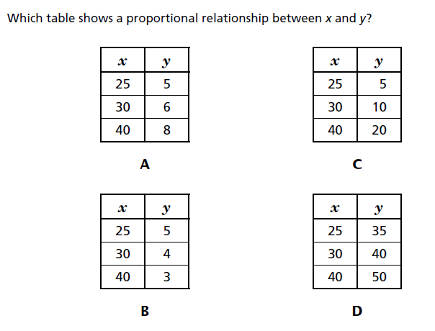

Name Date___________________
Assignment: Excellence, 7th Grade Math Team ______

Excellence: Speed Sheet
Directions: Determine whether each table represents a proportional relationship. Show your work for each table.

x y  5 15  6 18  7 21  8 24  Proportional? YES/NO | x y  5 75  9 135  2 30  6 90  Proportional? YES/NO | x y  2 26  3 39  6 78  10 130  Proportional? YES/NO
x y  1 100  3 300  5 550  6 600  Proportional? YES/NO | x y  2 90  3 135  5 225  6 270  Proportional? YES/NO | x y  8 2  16 4  24 6  32 8  Proportional? YES/NO
x y  0 0  1 9  2 18  3 27  Proportional? YES/NO | x y  1 4  2 5  3 6  4 7  Proportional? YES/NO | x y  2 8  4 16  6 24  8 32  Proportional? YES/NO

Name________________________ Date_______________
7th Grade Math IA 3, L066 (Proportional Relationships) Team____________

Constant of Proportionality

Key Takeaways:
______________________________________________________________________________________________________________________________________________
______________________________________________________________________________________________________________________________________________
______________________________________________________________________________________________________________________________________________
______________________________________________________________________________________________________________________________________________
______________________________________________________________________________________________________________________________________________
______________________________________________________________________________________________________________________________________________
______________________________________________________________________________________________________________________________________________
______________________________________________________________________________________________________________________________________________

Everybody Writes!
_______________________________________________________________________
_______________________________________________________________________
______________________________________________________________________________________________________________________________________________

STAMP
______________________________________________________________________________________________________________________________________________
_______________________________________________________________________
_______________________________________________________________________
Explore!

Ms. Logrieco needs to go to a grocery store to buy some cereal.

The chart below shows the cost structure for cereal boxes at Price Chopper Grocery Store.

Price Chopper Grocery Store
# of Cereal Boxes (x) | Cost (y)
2 | $6
4 | $12
6 | $18
8 | $24
17 | ?

- What is the cost of one box of cereal?

- What is the cost of 17 boxes of cereal? See if you can find more than one way to determine the answer.

Additional At-Bats
Definition: Constant of Proportionality

1. The cost of renting a bike is shown in the table below.

x | Hours | 0 | 1 | 2 | 3 | 5 | 8
y | Price | $0 | $6.50 | $13 | $19.50

a) What is the constant of proportionality? What does it represent in the context of this problem?

_____________________________________________________________________________________________________________________________________________________________________________________________

b) Use the constant of proportionality to complete the table.

2. The distance an ant traveled over time is shown in the table below.
x | Hours | 0 | 4 | 8 | 12 | 16
y | Miles | 0 | 1 | 2 | 3 | 4

a) What is the constant of proportionality? What does it represent in the context of this problem?

_____________________________________________________________________________________________________________________________________________________________________________________________

Priority Practice:
- Each of the tables below shows a proportional relationship. Which relationship does NOT have the same constant of proportionality as the other three?
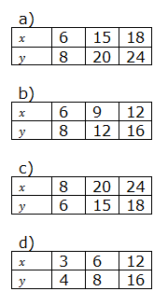

- What is the constant of proportionality in the table below?
x | 5 | 10 | 20
y | 4 | 8 | 16

(a) 1
(b) -1
(c) $\frac{4}{5}$
(d)$\frac{5}{4}$

- The table shows the number of wrist bands produced by a machine during a 16-hour work day.
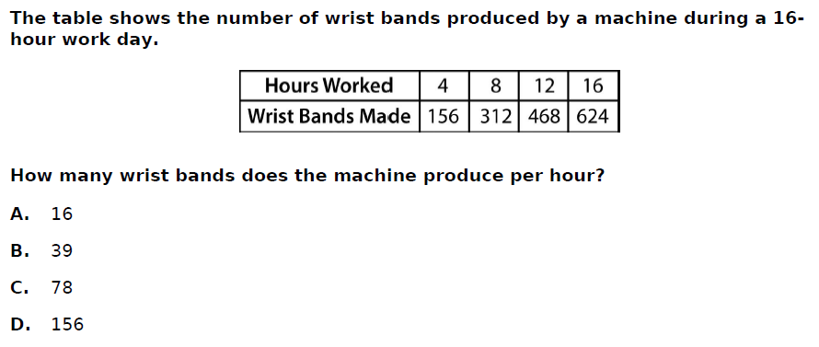

How many wrist bands does the machine produce per hour?

- 16
- 39
- 78
- 156

- The constant of proportionality of the table is $\frac{1}{4 } or 0.25.$ Fill in the table below.

Number of candies (x) | 2 | 4 | 5 | 10
Price (y) | 0.50

- What does the constant of proportionality represent in the context of the problem?
______________________________________________________________________________________________________________________________________________________________________________________________________________________________________________________________________________________________________

Extra Practice
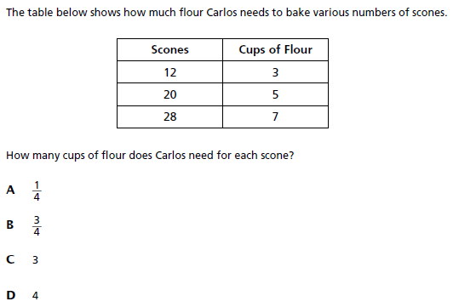
5) The table below shows how much flour Carlos needs to bake various numbers of scones.

Carlos believes that he needs 4 cups of flour for each scone. Explain whether you agree or disagree and why.

6) Four local stores sell the same brand of cheddar cheese. The table below shows how much each store charges.
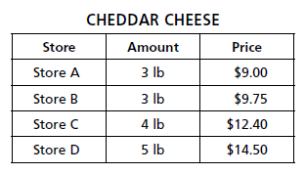

Part A: Which store has the lowest price per pound for the cheese?
- Store A
- Store B
- Store C
- Store D

Part B: Which store has the highest price per pound for the cheese?
- Store A
- Store B
- Store C
- Store D

7) The table below shows the relationship between the number of minutes Ronnie spent working on his math homework, and the number of problems that he completed.

x | Time Spent (Minutes) | 5 | 10 | 15
y | Problems Completed | 2 | 4 | 6 | 10

- What is the constant of proportionality?
- How long would it take Ronnie to complete 10 problems?
- What does the constant of proportionality represent in the context of this problem?

8) The table below shows the relationship between the amount of gas that a car uses and the distance that it travels.
x | Gas (Gallons) | $$5\frac{1}{2}$$ | $$9\frac{1}{2}$$ | $$17\frac{1}{2}$$
y | Distance (Miles) | $$71\frac{1}{2}$$ | $$123\frac{1}{2}$$ | $$227\frac{1}{2}$$
- What is the constant of proportionality?
- What does the constant of proportionality represent in the context of this problem?
- How far could the car travel if it had 20 gallons of gas in its tank?

Olympiad

Mary McDonald makes mugs in Miami. She makes two sizes of mugs: a small mug that she sells for $2.50 and a large mug that she sells for $5.75. Yesterday Mary made $56. Before she opened her shop in the morning, she had 200 mugs in her inventory. At the end of the day she has 188. How many mugs of each price did she sell?

Name________________________ Date_______________
7th Grade Math IA 3, L066 (Proportional Relationships) Team____________

Exit Ticket (NY)

1. The total number of hours Isaiah spends practicing basketball is proportional to the number of weeks that pass.
- Fill in the table below.
- What is the constant of proportionality?
- What does the constant of proportionality mean in the context of this problem?

Weeks (x) | Total Practice Hours (y)
0
1
2 | 6.5
3 | 9.75
4 | 13
5

______________________________________________________________________
______________________________________________________________________
______________________________________________________________________
______________________________________________________________________
______________________________________________________________________
______________________________________________________________________
Name________________________ Date_______________
7th Grade Math IA 3, L066 (Proportional Relationships) Team____________

Exit Ticket (NJMA)

1. The total number of hours Isaiah spends practicing basketball is proportional to the number of weeks that pass.
- Fill in the table below.
- What is the constant of proportionality?
- What does the constant of proportionality mean in the context of this problem?

Weeks (x) | Total Practice Hours (y)
0
1
2 | 6.5
3 | 9.75
4 | 13
5

______________________________________________________________________
______________________________________________________________________
______________________________________________________________________
______________________________________________________________________
______________________________________________________________________
______________________________________________________________________
Name________________________ Date_______________
7th Grade Math IA 3, L066 (Proportional Relationships) Team____________

Constant of Proportionality – Tables Homework

- Which of the following tables does NOT have a constant of proportionality?

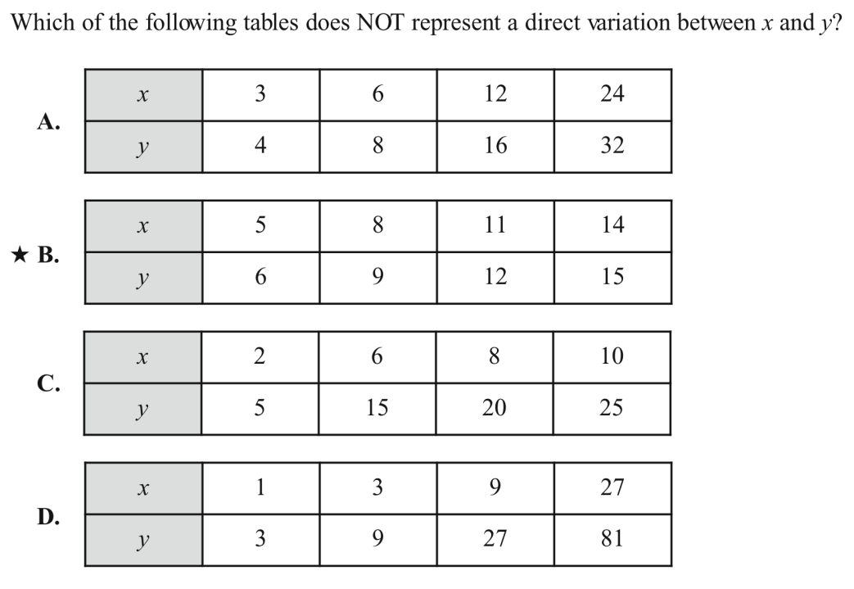

- Does this table show a proportional relationship? Show & explain why or why not.

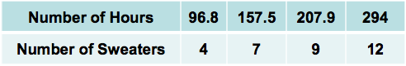

- Lunches in the high school cafeteria are $2.25 each. Make a table below to show this relationship.

Lunches
Cost

Mixed Review (Do not use a calculator on problems 2-4!)


- Years from now, Olamide will have to drive 324 miles to get from MIT back to her parents’ house in Newark. It will take her 4 hours and 45 minutes. What is her average speed, in miles per hour?

- Convert to decimal:

- Divide: -7.45 ÷ -0.5

4. $\frac{2}{3}-\left(\frac{1}{8}+\frac{3}{4}\right)×\frac{1}{2}$

